**1 - Investigate the adjacency matrix of the path graph.**

**2 - Create a function called mat_path(n) such that it receives a natural number n and returns the adjacency matrix of the path graph with n vertices.**

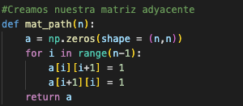

Here is the function that returns the adjacency matrix of the path graph, with n vertices defined as the argument of the function.

**3 - For n = 500 and 1000, calculate the eigenvalues of that matrix and create histograms of those values.**

Using this code, we can compute the eighteen values of the matrix that we can calculate using the former function we defined:

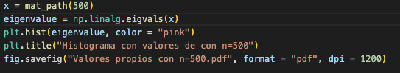

We can then do the same with n = 1000 and we obtain the following histograms.

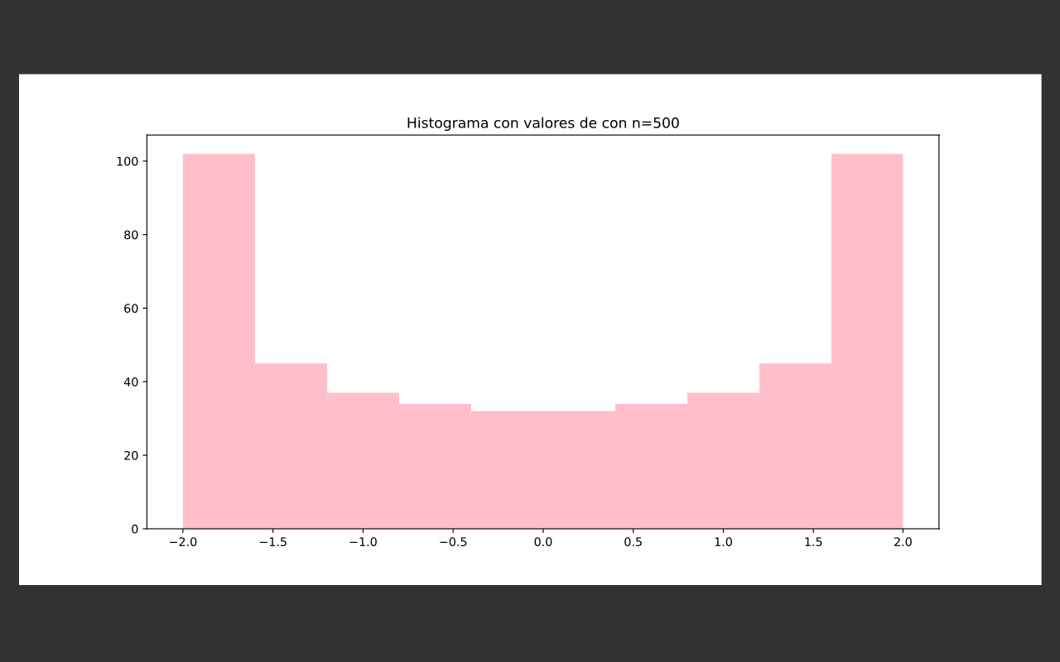

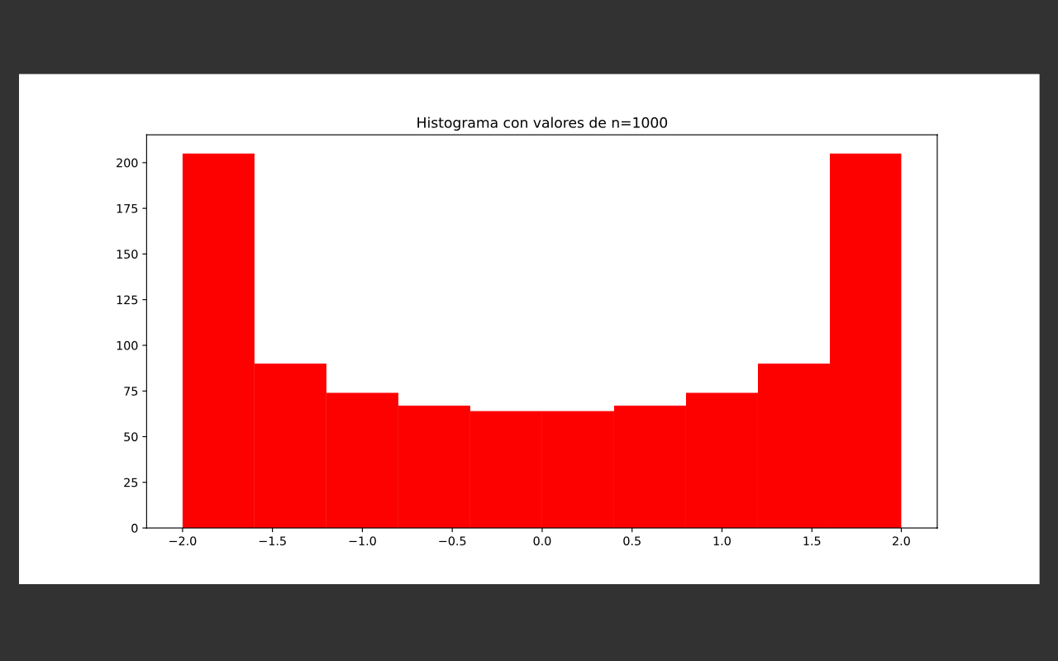

**4 - Generate a list such that for each k from 1 to n has the value of 2 cos((k*pi) / ( n + 1 ))**

**We define a function that takes a list and adds at the end the value asked. We can change the value of n when calling the function.**

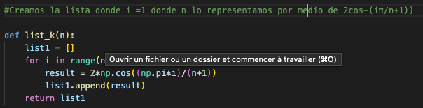

**5 - Creates histograms of such lists with n = 500 and 1000**

**To create the histograms, we use the function we described in question 4. We can call it and plot the result for n = 500 and n = 1000.**

**6 - Verify that the histograms are similar, what can you conjecture?**

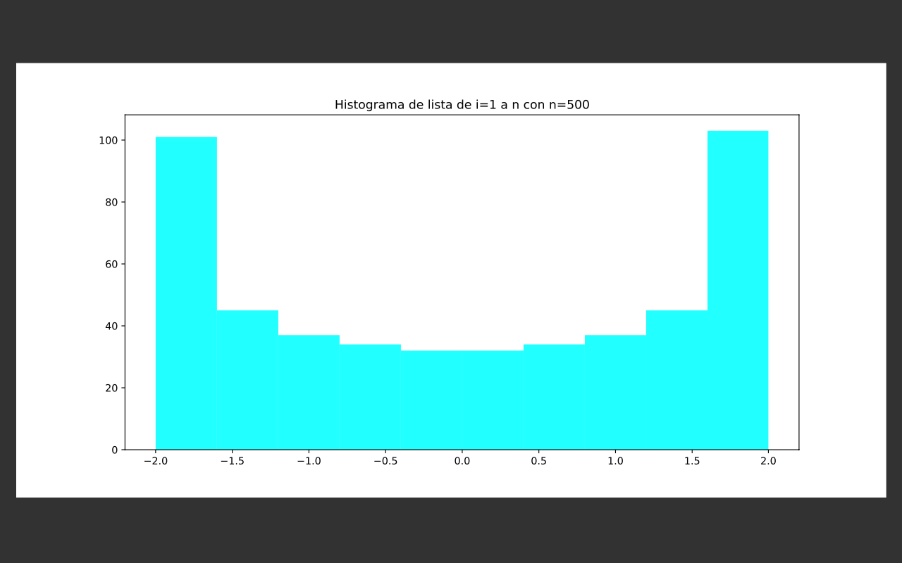

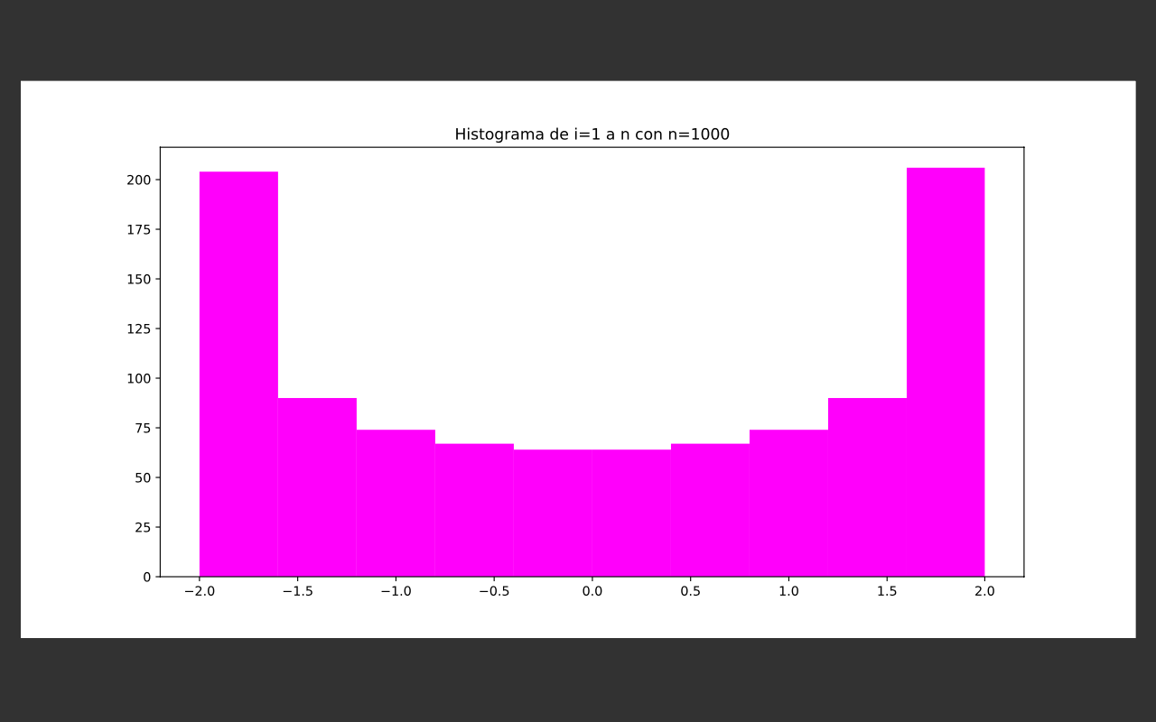

**We can see we get the exact same distribution with the two lists. This is due to the fact that the function is periodic.**